How to Update the Firmware
Hardware is the physical part of a micro:bit.
Software is made up of the programs you write and run on your micro:bit.
Firmware is in the middle: a special kind of software that makes devices function properly. It’s physically stored in the micro:bit’s interface chip and doesn’t change when you write programs or turn your micro:bit off, but it can be updated.
The micro:bit will work with the firmware it came with, but there may be times when you may want to update the firmware to use new features like WebUSB.

Checking your firmware version
To find out what version of the firmware you have on your micro:bit, Plug it in via USB, open up the DETAILS.TXT file from the MICROBIT drive and look for the number on the line that begins 'Interface Version'. In this example, the firmware version is 0254:
# DAPLink Firmware - see https://mbed.com/daplink
Unique ID: 9904360249624e45004a601400000027000000009796990b
HIC ID: 9796990b
Auto Reset: 1
Automation allowed: 0
Overflow detection: 0
Incompatible image detection: 1
Page erasing: 0
Daplink Mode: Interface
Interface Version: 0254
Bootloader Version: 0254
Git SHA: ec3fec91e815b1fe27cefb8bc4ffa85ca3317502
Local Mods: 0
USB Interfaces: MSD, CDC, HID, WebUSB
Bootloader CRC: 0xdb256cca
Interface CRC: 0xd0f0bacf
Remount count: 0
URL: https://microbit.org/device/?id=9904&v=0254

How to update the firmware
- Download the hex file from this page to your computer.
- Down load the latest firmware---0255(we also provide you with it in the folder)
https://www.microbit.org/get-started/user-guide/firmware/

Disconnect the USB cable and battery pack from the micro:bit.
Hold the reset button at the back of the micro:bit and plug the USB lead into the micro:bit and a computer. You should see a drive appear in your file manager called MAINTENANCE (instead of MICROBIT).

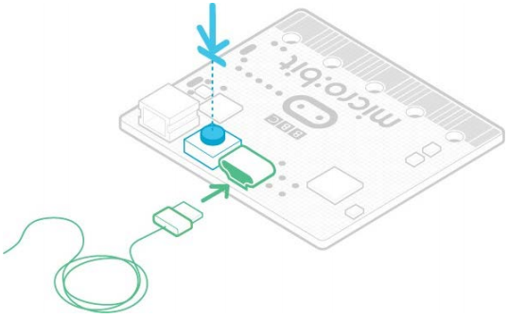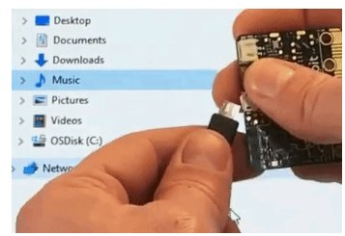

The MAINTENANCE drive will look like this, depending on your computer:

Windows

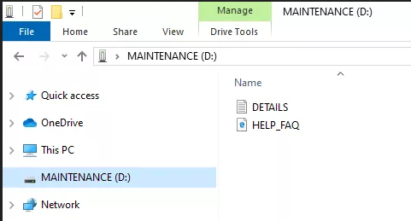

macOS
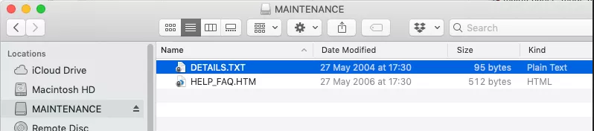

- Download the hex file from this page to your computer.
(in the KS0426 folder)
- Drag and drop the new firmware .HEX file you downloaded from this page onto the MAINTENANCE drive and wait for the yellow LED on the back of the device to stop flashing. When the upgrade is completed, the micro:bit will reset, ejecting itself from the computer and re-appear in normal MICROBIT drive mode.
- Finally, check the DETAILS.TXT file that is on the MICROBIT drive and make sure that it has the same version number as the .HEX firmware that you just downloaded and flashed to the interface chip.

